LINCOLN HIGH SCHOOL THEATRE ARTS
Michael Williams, Director
2600 SW 9th Street, Des Moines, IA, 50315
Michael.Williams@dmschools.org

Please consider purchasing a personal advertisement in the playbills for the productions

A great way to show your support for your performer/technician!!
We ask that you provide either a picture and text or text only ad via
E-mail (michael.williams@dmschools.org). (J-peg formats are preferred)
PLEASE NO PDF FILES AS WE CANNOT ADJUST TO FIT IN THE FOMATTING.
If you wish to purchase an ad, please fill out the form attached.

ADVERTISEMENT PACKAGES:
Ad Sizes | Cost
Full Page  5.5’’ x 8.5’’ | $40
½ Page  5.5’’ x 4.25’’ | $30
¼ Page  2.75’’ x 4.25’’  or  2.13’’ x 5.5’’ | $20
One Line Listing | $10
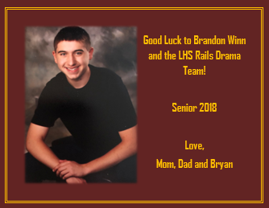

Example of Personal Ad

I have purchased an ad that is a:
____ full-page ____ ½ page ____ ¼ page ____ 1 line listing

For the season(s) of:
____Fall ____Fall and Spring

And I will submit a:
____slogan and logo ____ready-print add

WE MUST RECEIVE THE ADS THREE WEEKS BEFORE THE SHOW
**We greatly appreciate your support of the Theatre Program. We offer access to ALL our students to several opportunities in theatre production and performance

Please return this form to the Lincoln Theatre Arts Department either via
- The Student salesperson
- email at Michael.williams@dmschools.org , or
- send to “Michael Williams, Lincoln High School, 2600 SW 9th Street, Des Moines, IA, 50315”
Thank you!

I __________________________________________ agree to purchase an ad that is a:
(Contact Name)

____ full-page ____ ½ page ____ ¼ page ____ 1 line listing

And I will submit a:

_______ Picture and text _______ Text only

Full Address: ____________________________________________________________

Phone Number: __________________________________________________________

Email Address: __________________________________________________________

Signature of Advertiser: ___________________________________________________

